T. Jeslet Jessica
(192524135)
B. TECH AIDS
CSA0603 DESIGN AND ANALYSIS FOR ALGORITH
DAA Case Study
Hospital Patient Record Sorting Using Merge Sort

1. Description of the Real-World Problem
Hospitals handle thousands of patient records every day. These records must be sorted by admission time so doctors, nurses, and administrators can quickly access patient information. As the number of records increases, sorting must remain fast, accurate, and reliable.

2. Problem Statement
Design a system to sort hospital patient records based on admission time using the Merge Sort algorithm. The system should:
Sort records correctly. Maintain the order of patients with the same admission time (stable sorting). Handle large numbers of patient records efficiently. Improve quick searching and reporting.

3. Algorithm Used
Merge Sort (Divide and Conquer Algorithm)
Steps
Divide the patient record list into two halves. Continue dividing until each list contains one record. Merge the divided lists in sorted order. Repeat until the complete sorted list is obtained.
4. Justification for Choosing the Algorithm (Why Merge Sort?)
- Stable sorting (keeps same admission time records in original order).
- Works efficiently for large datasets.
- Time complexity remains O(n log n) in all cases.
- Suitable for hospital databases where accuracy is important.
- Reliable and predictable performance.

5. Complexity Analysis
Case | Time Complexity
Best Case | O(n log n)
Average Case | O(n log n)
Worst Case | O(n log n)
Space Complexity | O(n)

6. Manual Execution (Step-by-Step Process)
Input
Patient | Admission Time
P1 | 10:30
P2 | 09:15
P3 | 11:00
P4 | 08:45

Step 1: Divide
[P1 P2 P3 P4]
↓
[P1 P2] [P3 P4]
↓
[P1] [P2] [P3] [P4]
Step 2: Merge
[P1] + [P2]
↓
[P2 P1]
[P3] + [P4]
↓
[P4 P3]
Step 3: Final Merge
[P2 P1] + [P4 P3]
↓
[P4 P2 P1 P3]
Final Sorted Order
Patient | Admission Time
P4 | 08:45
P2 | 09:15
P1 | 10:30
P3 | 11:00
7. Applications
- Hospital patient management systems
- Electronic Health Records (EHR)
- Medical report generation
- Emergency patient scheduling
- Hospital data analysis
8. Advantages
- Stable sorting.
- Efficient for large datasets.
- Predictable performance.
- Easy to implement.
- Suitable for linked lists and external sorting.
9. Limitations
- Requires extra memory.
- Slightly slower than Quick Sort for small datasets.
- More memory usage because of temporary arrays.
10. Comparison with Other Algorithms
Algorithm | Best | Average | Worst | Stable
Merge Sort | O(n log n) | O(n log n) | O(n log n) | Yes
Quick Sort | O(n log n) | O(n log n) | O(n²) | No
Bubble Sort | O(n) | O(n²) | O(n²) | Yes
Selection Sort | O(n²) | O(n²) | O(n²) | No

11. C Program (Merge Sort)
#include <stdio.h>

void merge(int arr[], int l, int m, int r)
{
int i, j, k;
int n1 = m - l + 1;
int n2 = r - m;

int L[n1], R[n2];

for(i = 0; i < n1; i++)
L[i] = arr[l + i];

for(j = 0; j < n2; j++)
R[j] = arr[m + 1 + j];

i = 0;
j = 0;
k = l;

while(i < n1 && j < n2)
{
if(L[i] <= R[j])
arr[k++] = L[i++];
else
arr[k++] = R[j++];
}

while(i < n1)
arr[k++] = L[i++];

while(j < n2)
arr[k++] = R[j++];
}

void mergeSort(int arr[], int l, int r)
{
if(l < r)
{
int m = (l + r) / 2;

mergeSort(arr, l, m);
mergeSort(arr, m + 1, r);

merge(arr, l, m, r);
}
}

int main()
{
int arr[10], n, i;

printf("Enter number of patients: ");
scanf("%d", &n);

printf("Enter admission times (HHMM):\n");

for(i = 0; i < n; i++)
scanf("%d", &arr[i]);

mergeSort(arr, 0, n - 1);

printf("\nSorted Admission Times:\n");

for(i = 0; i < n; i++)
printf("%d ", arr[i]);

return 0;
}

12. Input
Enter number of patients: 5
Enter admission times:
1030
0915
1100
0845
1000
13. Sample Output
Sorted Admission Times:
845 915 1000 1030 1100

14. Screenshot of the Program
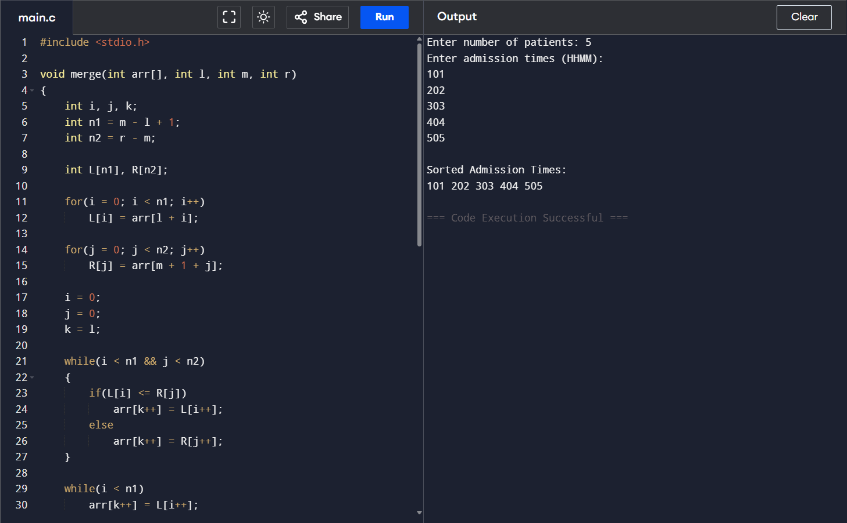

15. Conclusion
Merge Sort is an efficient and stable sorting algorithm suitable for hospital patient record management. It uses the divide-and-conquer approach to sort records quickly while maintaining data consistency. With O(n log n) time complexity in all cases, it performs well even for large hospital databases, making it a reliable choice for healthcare systems where accuracy an

